**EXPERIMENT 1**

**AIM: Installing Vagrant & Creating basic vagrant box using Virtual Box virtualization.**

1. Download and Install Oracle Virtual Box 5.x and Vagrant 2.2.7.

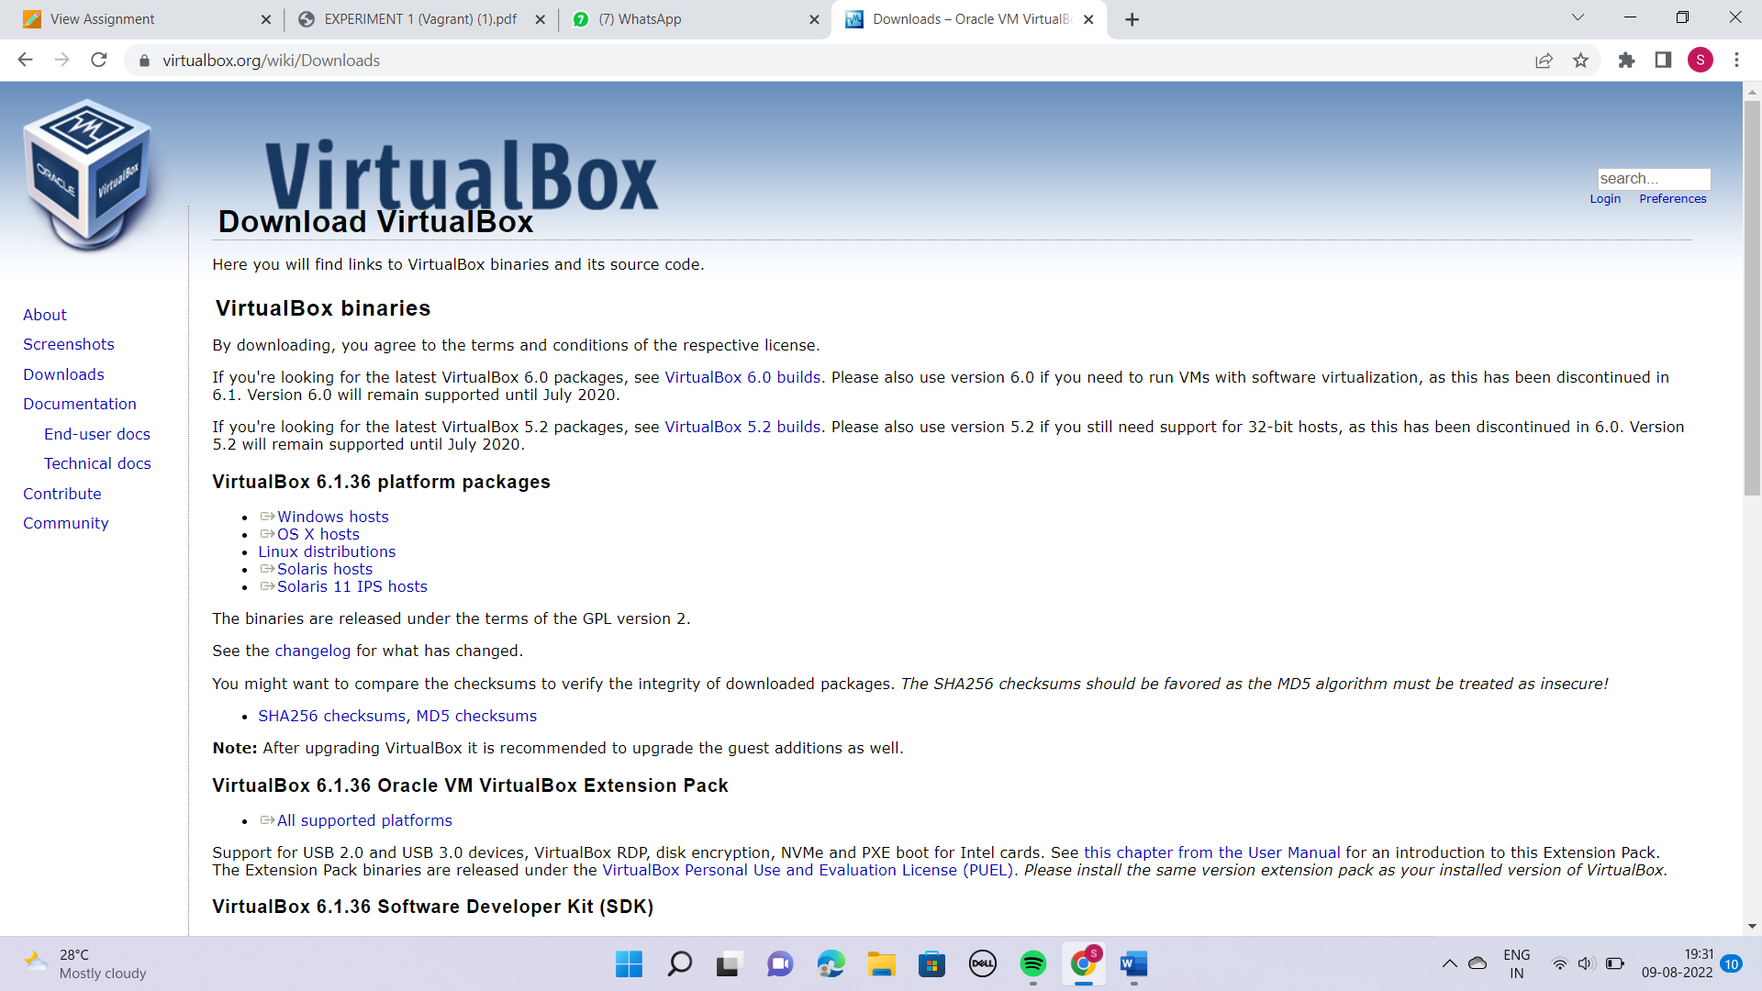

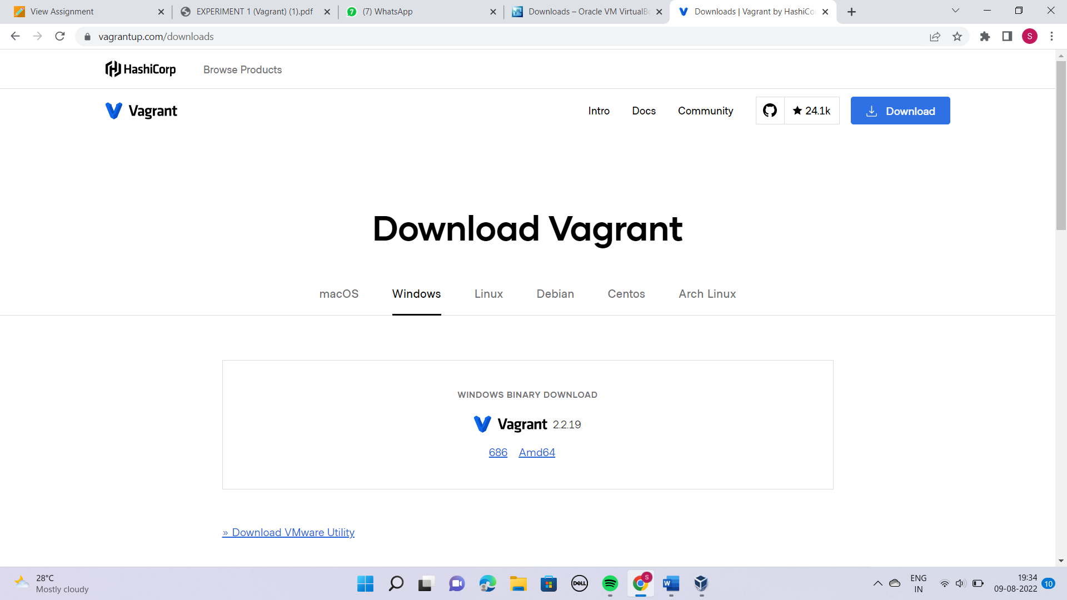

Step 2:- Check working of Vagrant using vagrant --version command.

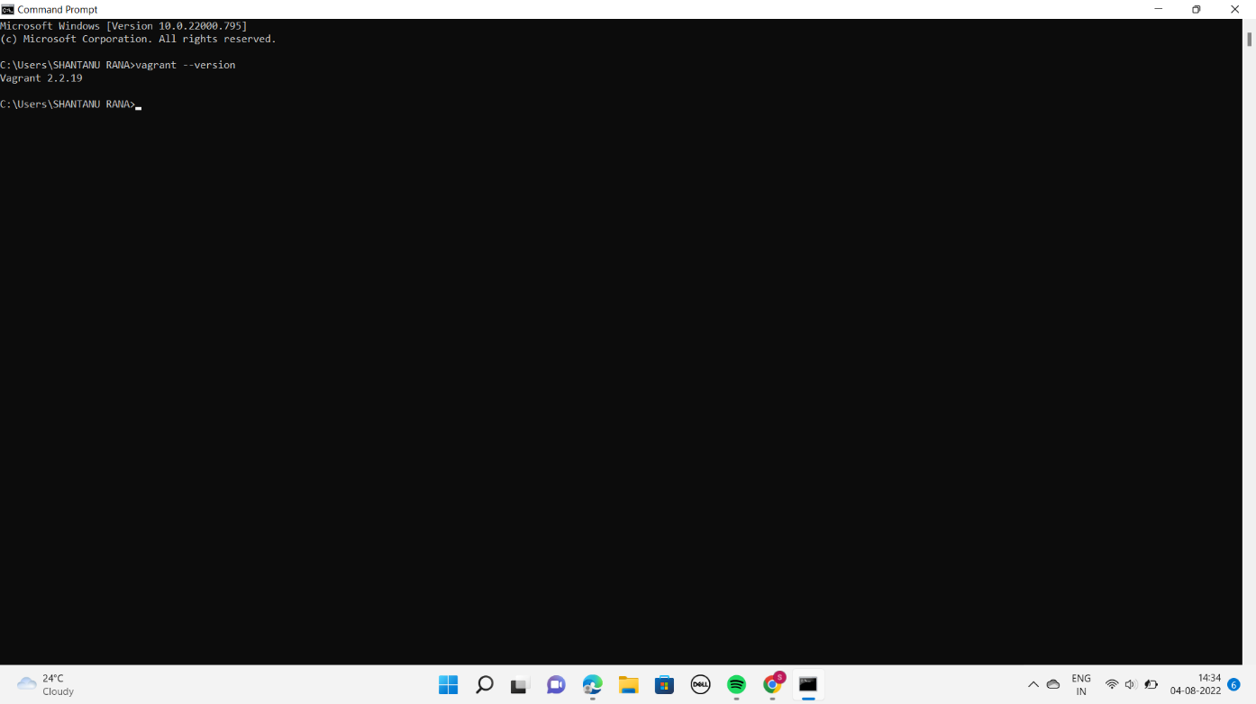

3. Create a new directory using CMD.

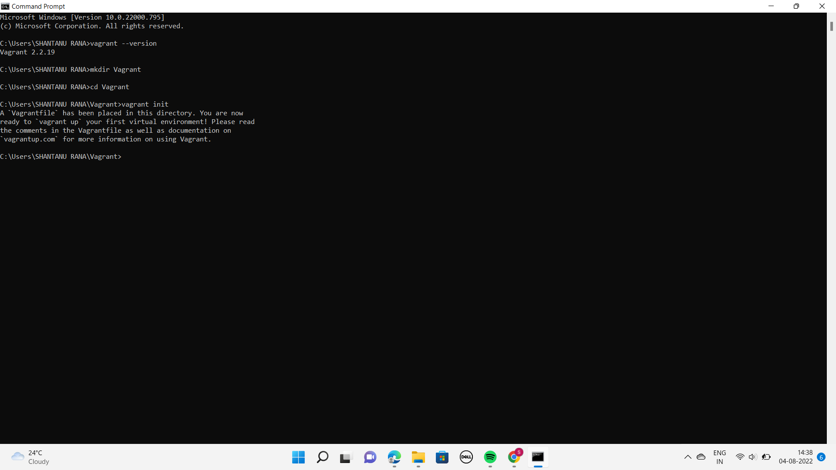

4. Run vagrant init command

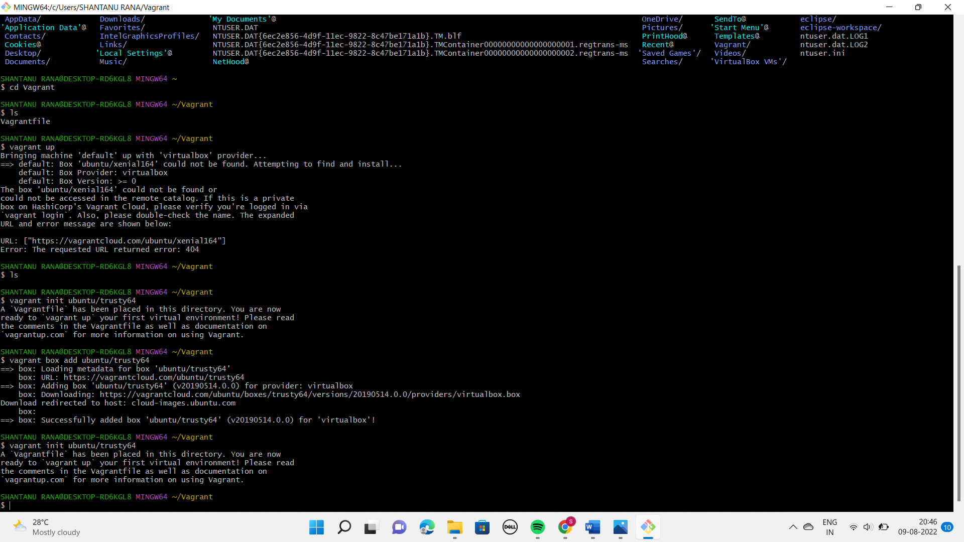

5. Edit vagrantfile and add ubuntu/trusty64 in box tag

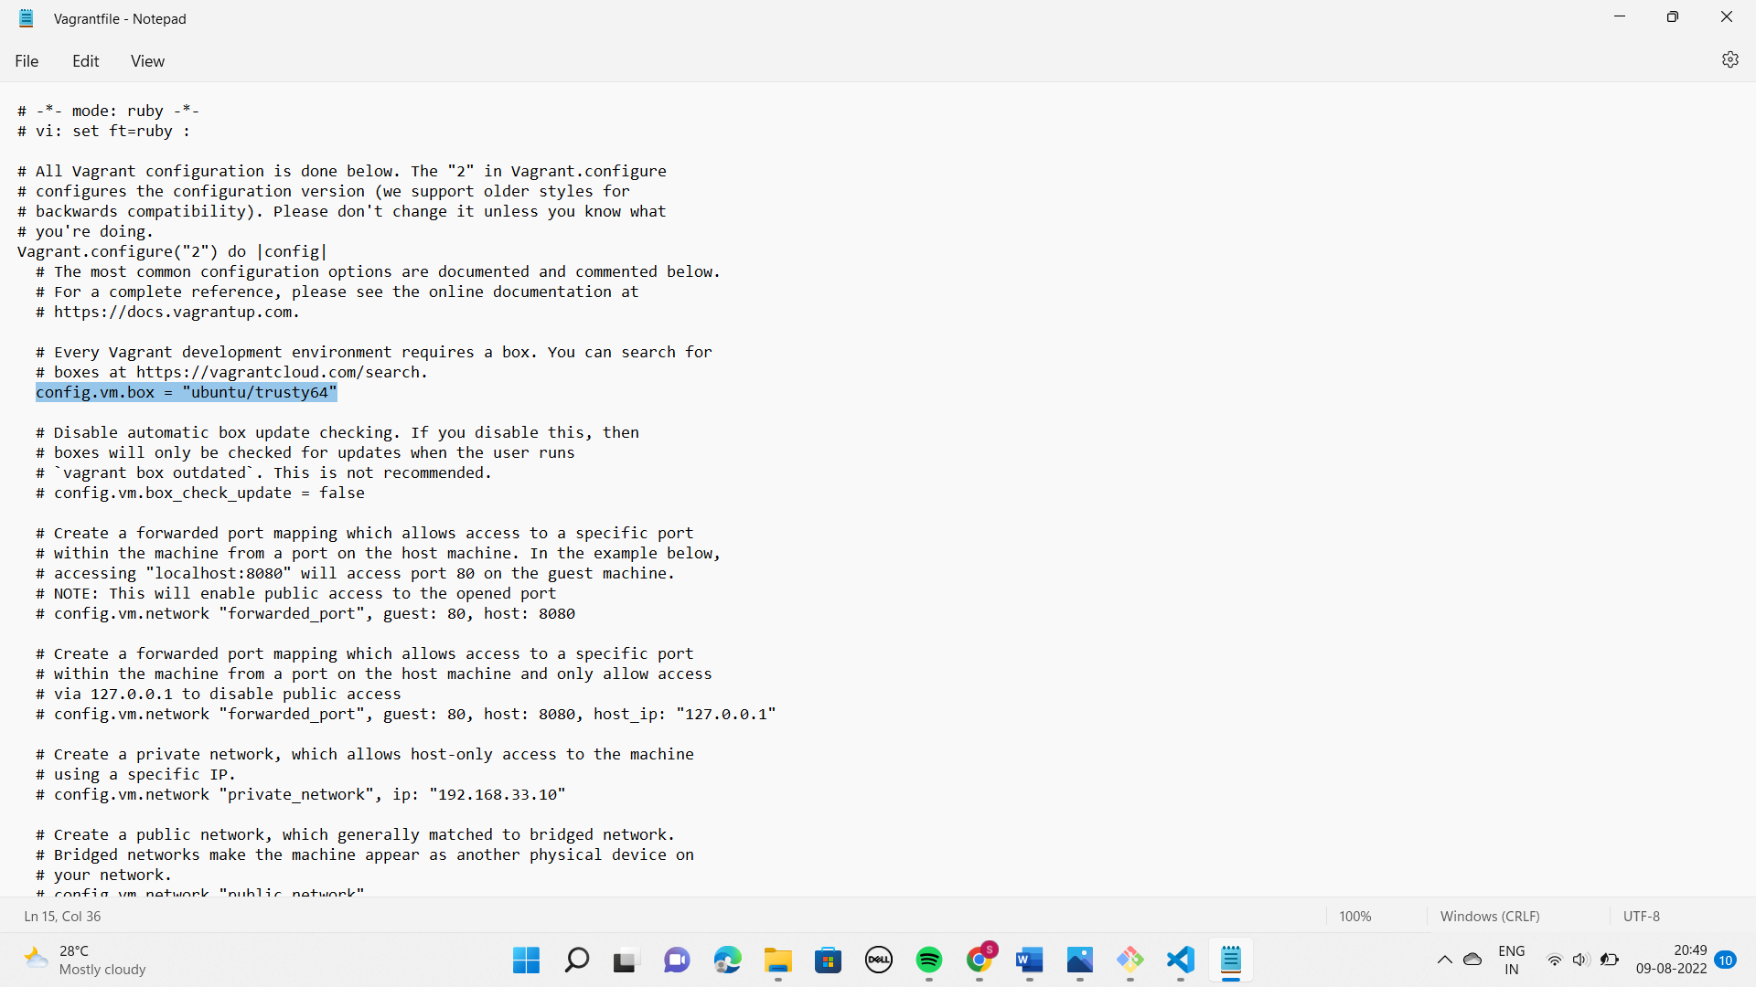

6. Run vagrant up command



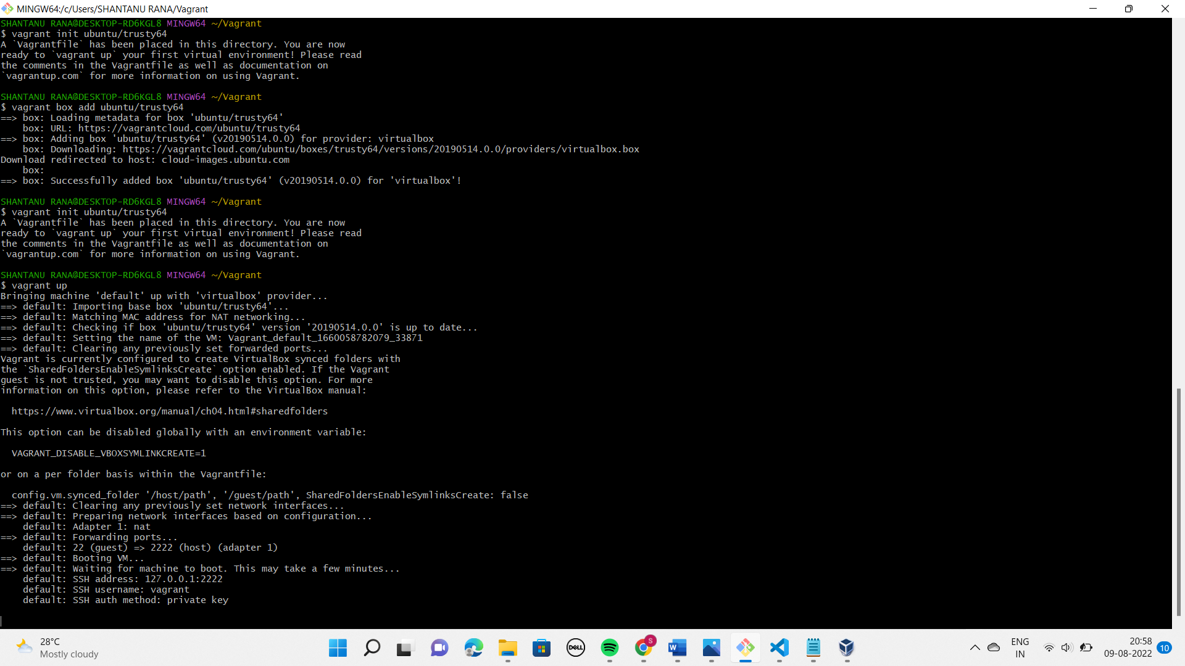

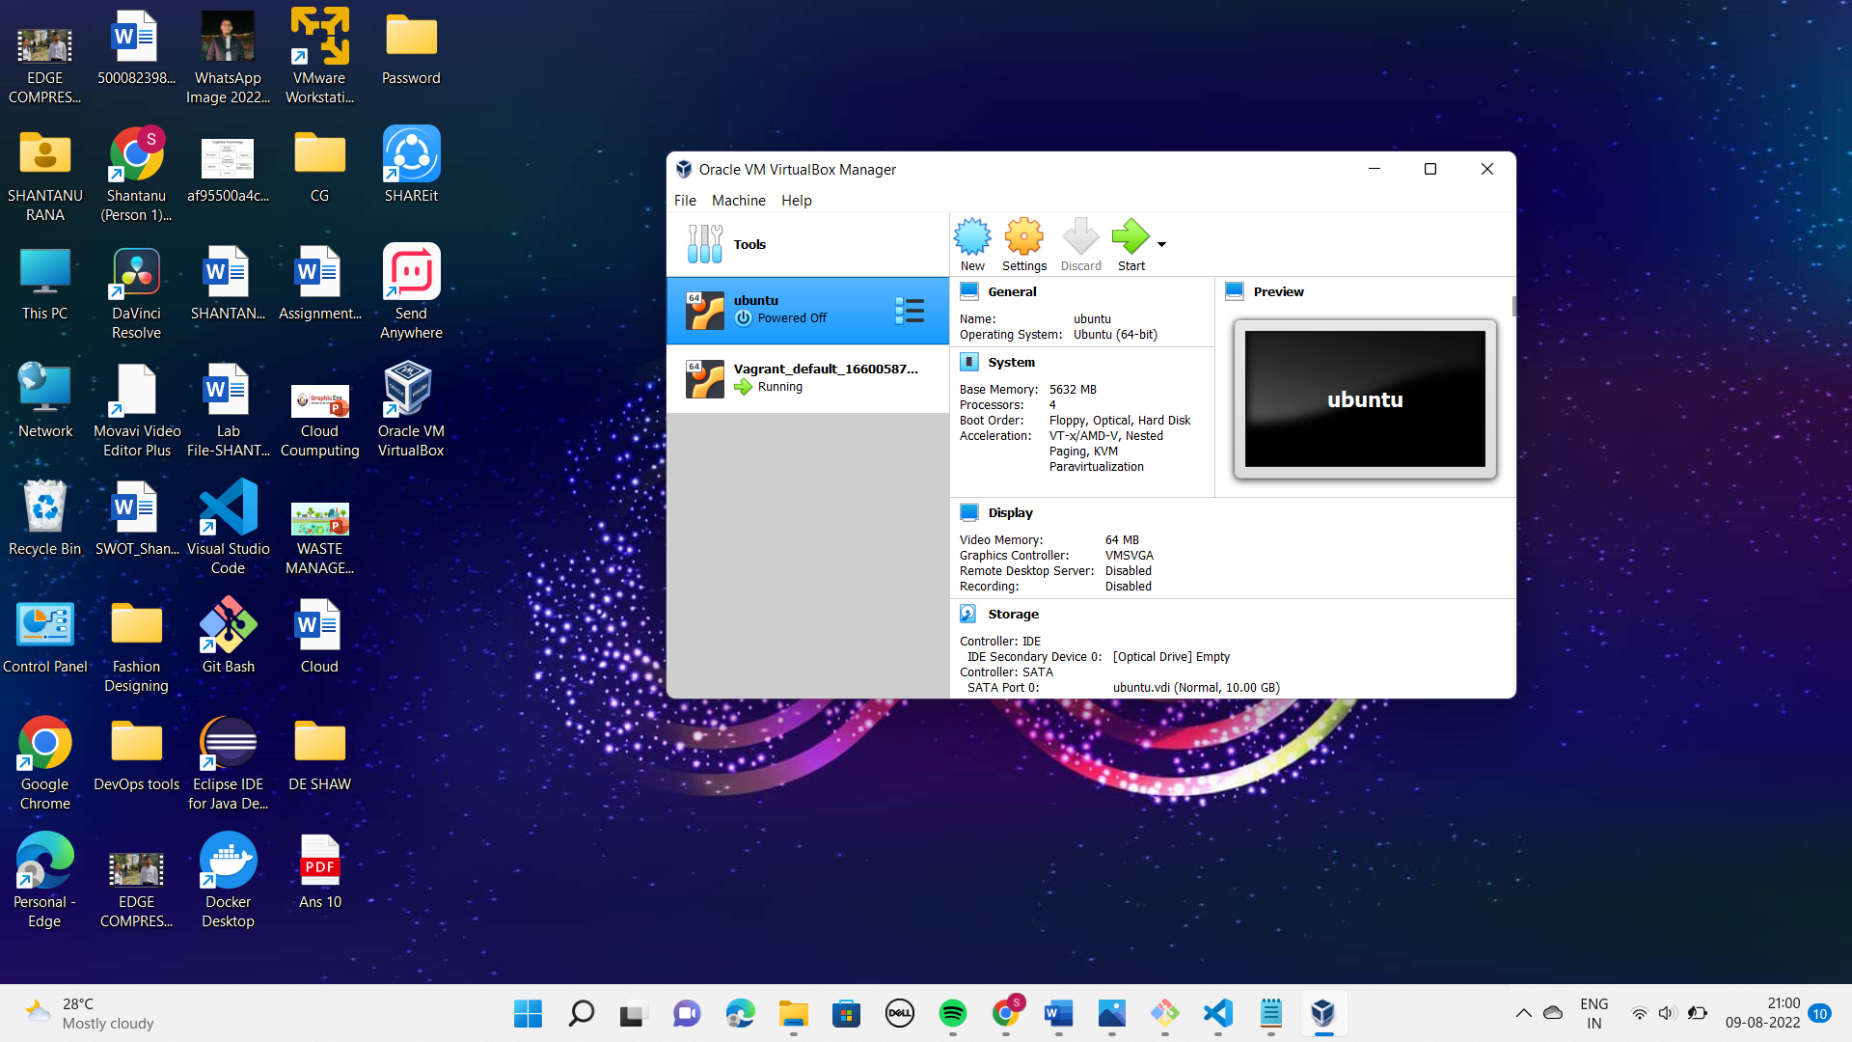

7. Run vagrant SSH command

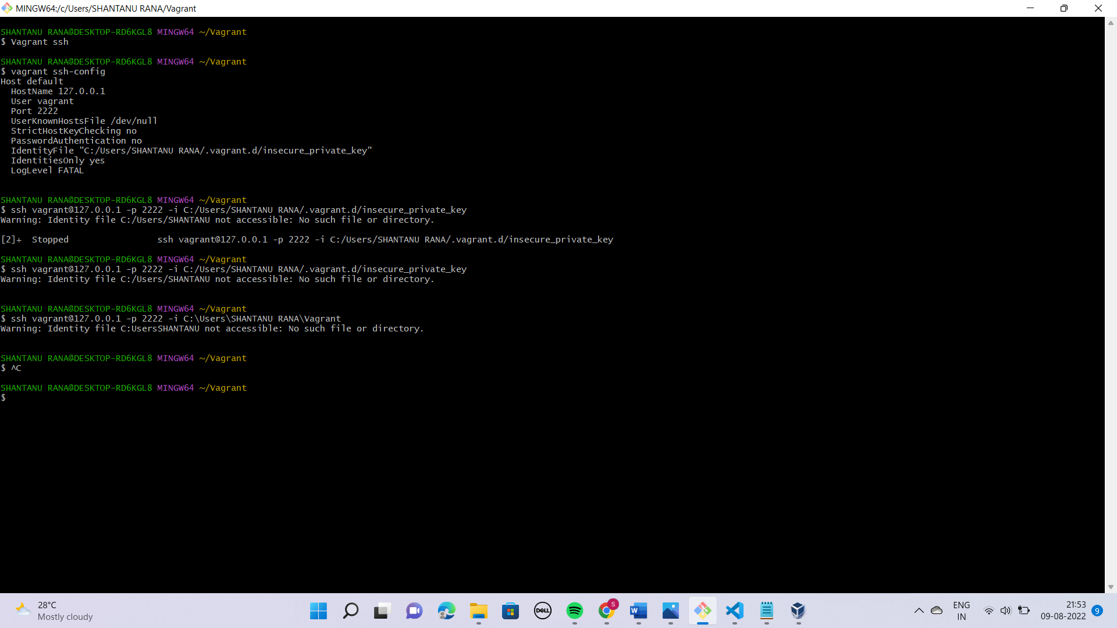

8. Run Vagrant Halt to stop VM

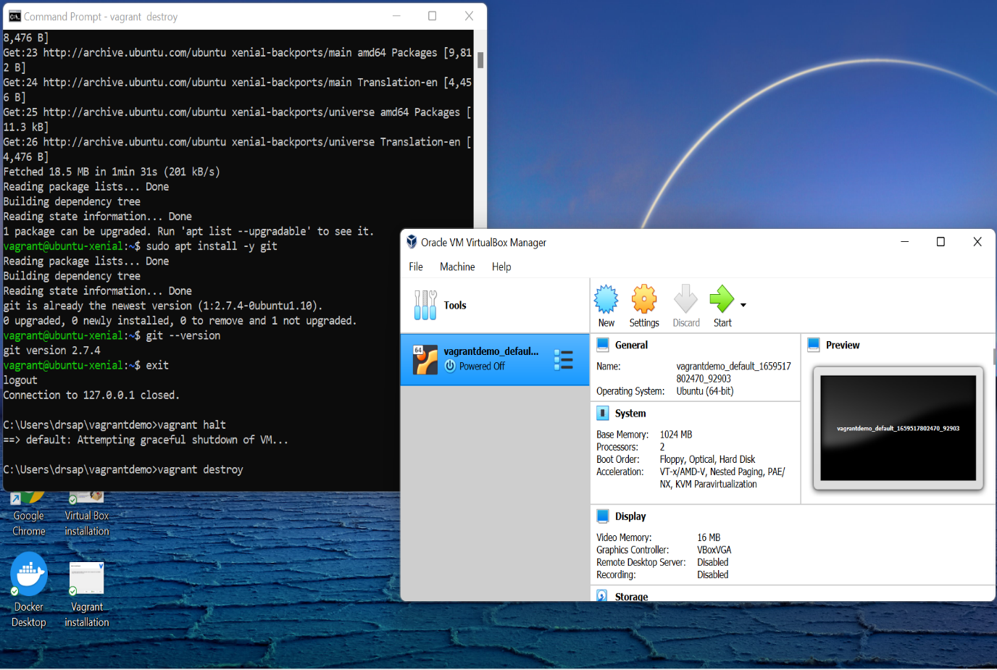

9.Run Vagrant Destroy to delete VM

